Public hospital research.

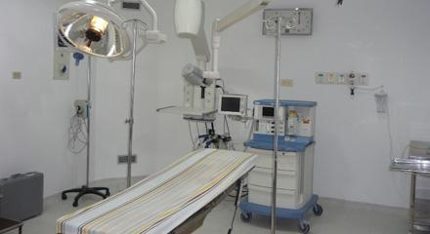

Public hospital operaiting room is well lighted and contains a large number of up to date equiptment.

* Surgical tables
* Medical Equipment cart
* Lighting
* HR machine
* Medicine cabinets

<http://www.midmed.com.au/product-portfolio>

lists of treatment in public hospitals.

* Cancer treatment
* X-rays
* Surgery
* Wound treatment
* Blood tests
* Diabetic treatment and check ups
* transplants

atmophere in doctors.

When entering any public hospital it is always a warm and welcoming enviroment which welcoms all kinds of patients. The surroundings are always well lighted which prevents a negative feeling when in the enviroment of care.

<https://www.youtube.com/watch?v=qGulU83N6Gc>

the video link above is filmed by the guardian, it shows the insights of being an NHS worker and the effects the job does to the people who work in this enviroment.